Sri Lanka Institute of Information

Technology



Lab Submission

06

**IT24103228**

**Fonseka N.H.D.K**

**Probability and Statistics - IT2120**

B.Sc. (Hons) in Information Technology

**Exercise**



Question 01.

i. What is the distribution of X?

ii. What is the probability that at least 47 students passed the test?

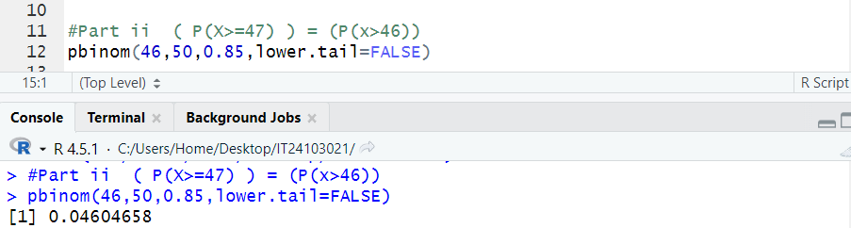

Question 02.

i. What is the random variable (X) for the problem?

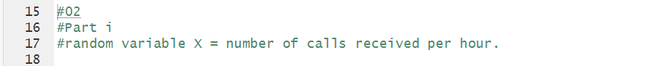

ii. What is the distribution of X?

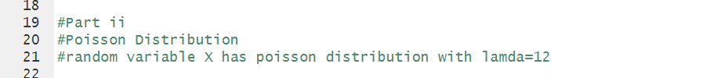

iii. What is the probability that exactly 15 calls are received in an hour?

